Lecture 2 – Gaussian Models
Scenario: Noisy temperature sensor, true temperature μ = 22C.
Setup:
- Measurement noise: σ = 1.5C ⇒ λ = 0.444.
- Prior: μ₀ = 20C, σ₀ = 3C ⇒ λ₀ = 0.111.
- 20 sequential readings, typical values: {20.1, 22.3, 21.8, 23.1, . . .}.
Describe the dynamics and the trend in a tabular format.
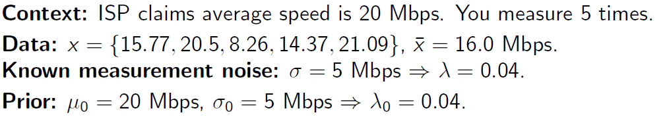
Calculate the Posterior.

